Choice of metric and tradeoffs
The metric(s) you choose to prioritize when evaluating the model and choosing a threshold depend on the costs, benefits, and risks of the specific problem. In the spam classification example, it often makes sense to prioritize recall, nabbing all the spam emails, or precision, trying to ensure that spam-labeled emails are in fact spam, or some balance of the two, above some minimum accuracy level.

Confusion matrix for assessing the performance of a model:
 |  | Predicted class
 |  | + | -
Actual class | + | TP  True Positives  Threshold ↑ → TP ↓ | FN  False Negatives  Type II Error  Threshold ↑ → FN ↑ | TPR, Recall, Sensitivity  $$\frac{TP}{TP+FN}$$  Correctly classified actual positives over all actual positives. Coverage of actual positive sample. Probability of detection.  Use when false negatives are more expensive than false positives.
Actual class | - | FP  False Positives  Type I Error  Threshold ↑ → FP ↓ | TN  True Negatives  Threshold ↑ → TN ↑ | TNR, Specificity  $$\frac{TN}{TN+FP}$$  Correctly classified actual negatives over all actual negatives. Coverage of actual negative sample. Model’s ability to correctly predict negative cases. | FPR, 1-Specificity  $$\frac{FP}{TN+FP}$$  Incorrectly classified actual negatives over all actual negatives. Probability of false alarm.  Use when false positives are more expensive than false negatives.
 |  | Precision  $$\frac{TP}{TP+FP}$$  Correctly classified actual positives over everything classified as positive. How accurate the positive predictions are.  Use when it's very important for positive predictions to be accurate. | Negative Predictive Value  $$\frac{TN}{TN+FN}$$  Proportion of classes giving negative results that are actually negative. It's a measure of how likely it is that someone who tests negative for a condition is actually healthy. | Accuracy  $$\frac{TP+TN}{TP+TN+FP+FN}$$  Correct classifications over total classifications. Overall performance of model.  Use as a rough indicator of model training progress/convergence for balanced datasets. For model performance, use only in combination with other metrics. Avoid for imbalanced datasets.

Threshold ↑ | TP ↓ FP ↓ TN ↑ FN ↑

Metrics commonly used to assess the performance of classification models
Metric | Guidance | Formula | Interpretation
Accuracy | Use as a rough indicator of model training progress/convergence for balanced datasets.  For model performance, use only in combination with other metrics.  Avoid for imbalanced datasets. Consider using another metric. | $$\frac{TP+TN}{TP+TN+FP+FN}$$ | Correct classifications over total classifications  Overall performance of model
TPR / true positive rate / Recall / Sensitivity | Use when false negatives are more expensive than false positives. | $$\frac{TP}{TP+FN}$$ | Correctly classified actual positives over all actual positives  Coverage of actual positive sample.  Probability of detection.
FPR / false positive rate / 1-Sensitivity | Use when false positives are more expensive than false negatives. | $$\frac{FP}{TN+FP}$$ | Incorrectly classified actual negatives over all actual negatives.  Probability of false alarm
Precision | Use when it's very important for positive predictions to be accurate. | $$\frac{TP}{TP+FP}$$ | Correctly classified actual positives over everything classified as positive  How accurate the positive predictions are
Specificity / TNR / true negative rate | Stanford, CS229 | $$\frac{TN}{TN+FP}$$ | Correctly classified actual negatives over all actual negatives  Coverage of actual negative sample
F1 score | This metric balances the importance of precision and recall and is preferable to accuracy for class-imbalanced datasets. | $$\frac{2TP}{2TP+FP+FN}$$ | Geometric (harmonic) mean of precision and recall  Hybrid metric useful for unbalanced classes
AUC / AUROC, i.e., area under the TPR vs FPR curve | Use when the dataset is roughly balanced.  If false positive (false alarms) are more costly, choose a threshold on the ROC with a lower FPR, even if TPR is reduced.  If false positives are cheap and false negatives (missed true positives) are highly costly, choose a threshold on the ROC maximising TPR | 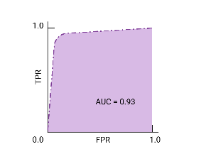 | Area under the ROC curve which was constructed by plotting TPR vs FPR.  A perfect model has TPR = 1, and FPR = 0.  A model with greater AUC is generally the better one
PR AUC / precision-recall curve | Use when the dataset is imbalanced | 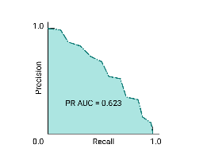 | Area under the ROC curve which was constructed by plotting Precision vs Recall

Classification: ROC and AUC
The previous section presented a set of model metrics, all calculated at a single classification threshold value. But if you want to evaluate a model's quality across all possible thresholds, you need different tools.

Receiver-operating characteristic curve (ROC)
The ROC curve is a visual representation of model performance across all thresholds. The long version of the name, receiver operating characteristic, is a holdover from WWII radar detection.
The ROC curve is drawn by calculating the true positive rate (TPR) and false positive rate (FPR) at every possible threshold (in practice, at selected intervals), then graphing TPR over FPR. A perfect model, which at some threshold has a TPR of 1.0 and a FPR of 0.0, can be represented by either a point at (0, 1) if all other thresholds are ignored, or by the following:
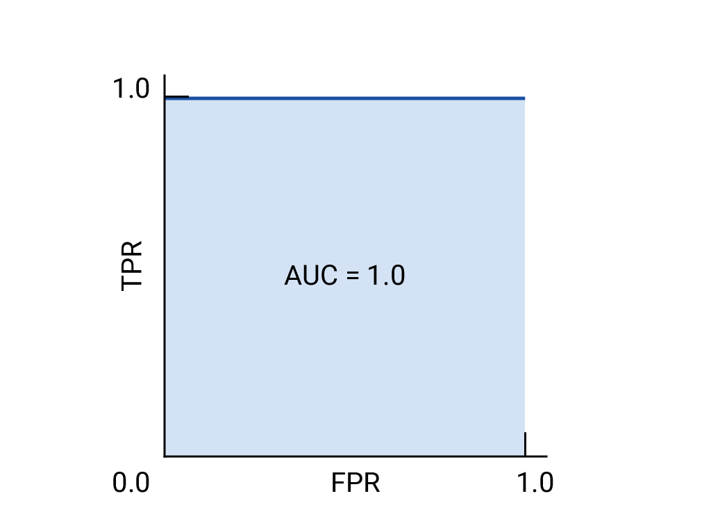Figure 1. ROC and AUC of a hypothetical perfect model.
Area under the curve (AUC or AUROC, i.e., area under the TPR vs FPR curve)
The area under the ROC curve (AUC) represents the probability that the model, if given a randomly chosen positive and negative example, will rank the positive higher than the negative.
The perfect model above, containing a square with sides of length 1, has an area under the curve (AUC) of 1.0. This means there is a 100% probability that the model will correctly rank a randomly chosen positive example higher than a randomly chosen negative example. In other words, looking at the spread of data points below, AUC gives the probability that the model will place a randomly chosen square to the right of a randomly chosen circle, independent of where the threshold is set.
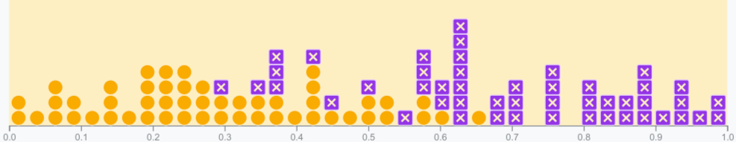
In more concrete terms, a spam classifier with AUC of 1.0 always assigns a random spam email a higher probability of being spam than a random legitimate email. The actual classification of each email depends on the threshold that you choose.
For a binary classifier, a model that does exactly as well as random guesses or coin flips has a ROC that is a diagonal line from (0,0) to (1,1). The AUC is 0.5, representing a 50% probability of correctly ranking a random positive and negative example.
In the spam classifier example, a spam classifier with AUC of 0.5 assigns a random spam email a higher probability of being spam than a random legitimate email only half the time.
In the spam classifier example, a spam classifier with AUC of 0.5 assigns a random spam email a higher probability of being spam than a random legitimate email only half the time.
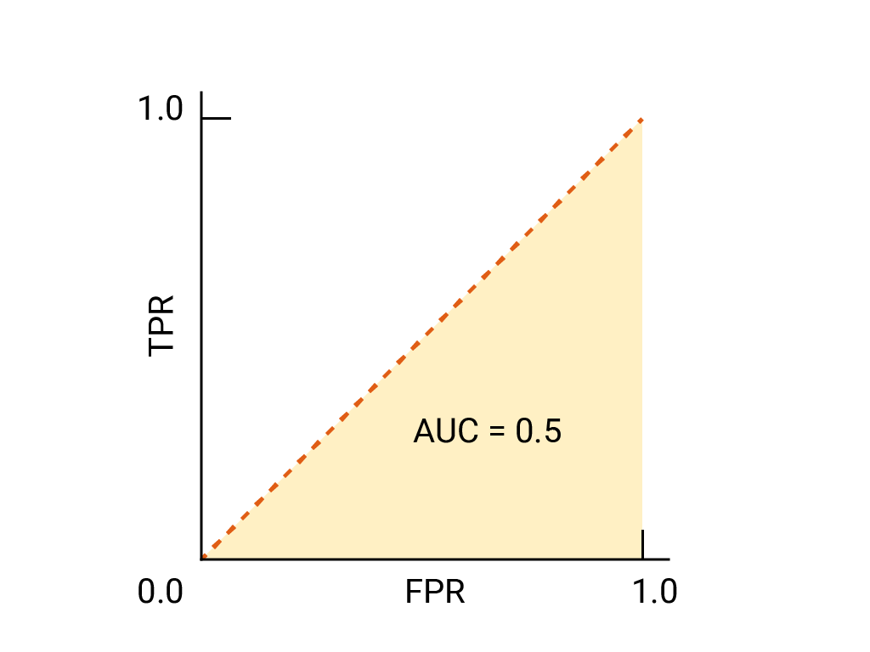Figure 2. ROC and AUC of completely random guesses.
(Optional, advanced) Precision-recall curve
AUC and ROC work well for comparing models when the dataset is roughly balanced between classes. When the dataset is imbalanced, precision-recall curves (PRCs) and the area under those curves may offer a better comparative visualization of model performance. Precision-recall curves are created by plotting precision on the y-axis and recall on the x-axis across all thresholds.
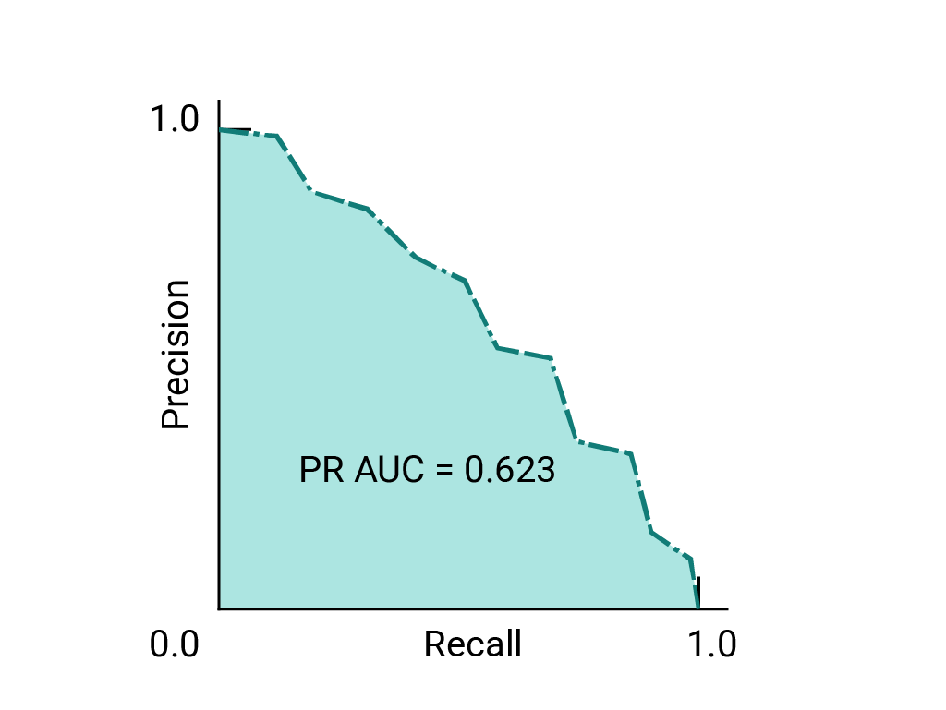
AUC and ROC for choosing model and threshold
AUC is a useful measure for comparing the performance of two different models, as long as the dataset is roughly balanced. (See Precision-recall curve, above, for imbalanced datasets.) The model with greater area under the curve is generally the better one.
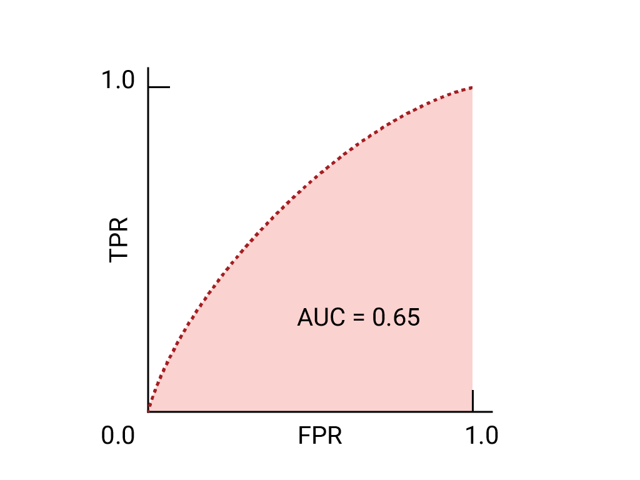 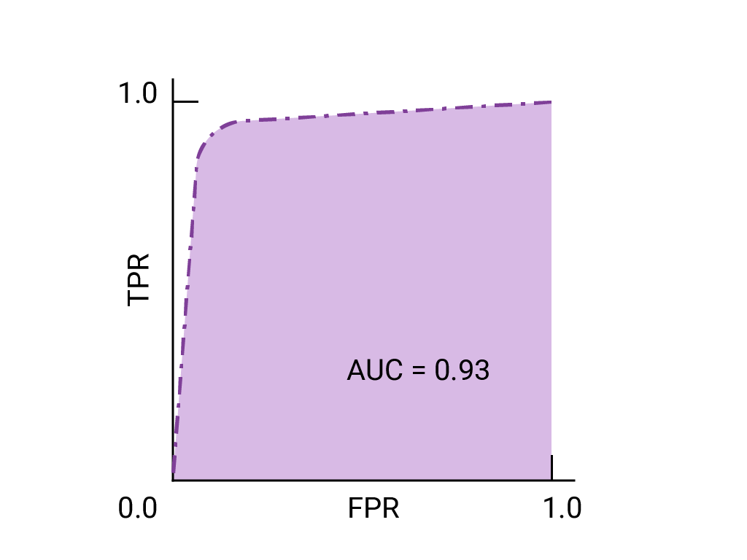Figure 3. ROC and AUC of two hypothetical models. The curve on the right, with a greater AUC, represents the better of the two models.
The points on a ROC curve closest to (0,1) represent a range of the best-performing thresholds for the given model. As discussed in the Thresholds, Confusion matrix and Choice of metric and tradeoffs sections, the threshold you choose depends on which metric is most important to the specific use case. Consider the points A, B, and C in the following diagram, each representing a threshold:
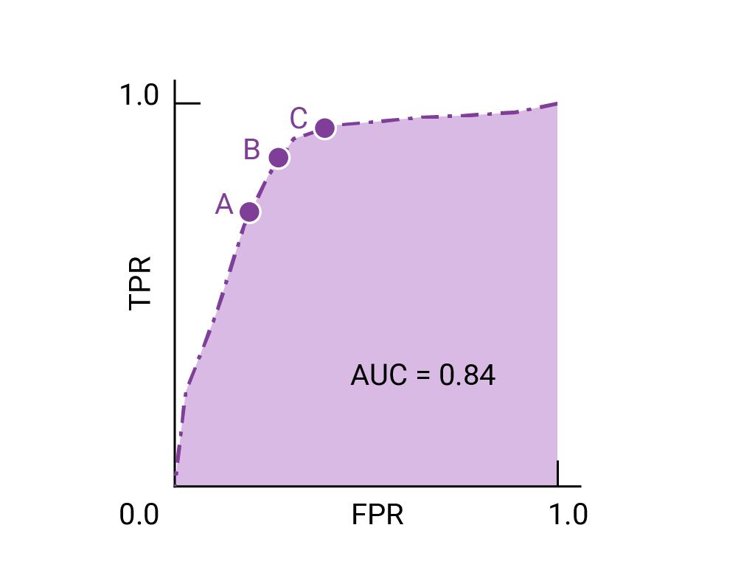Figure 4. Three labeled points representing thresholds.
If false positives (false alarms) are highly costly, it may make sense to choose a threshold that gives a lower FPR, like the one at point A, even if TPR is reduced. Conversely, if false positives are cheap and false negatives (missed true positives) highly costly, the threshold for point C, which maximizes TPR, may be preferable. If the costs are roughly equivalent, point B may offer the best balance between TPR and FPR.

Classification: Prediction bias
As mentioned in the Linear regression module, calculating prediction bias is a quick check that can flag issues with the model or training data early on.
Prediction bias is the difference between the mean of a model's predictions and the mean of ground-truth labels in the data. A model trained on a dataset where 5% of the emails are spam should predict, on average, that 5% of the emails it classifies are spam. In other words, the mean of the labels in the ground-truth dataset is 0.05, and the mean of the model's predictions should also be 0.05. If this is the case, the model has zero prediction bias. Of course, the model might still have other problems.
The bias of a model is the difference between the expected prediction and the correct model that we try to predict for given data points.
If the model instead predicts 50% of the time that an email is spam, then something is wrong with the training dataset, the new dataset the model is applied to, or with the model itself. Any significant difference between the two means suggests that the model has some prediction bias.
Prediction bias can be caused by:
- Biases or noise in the data, including biased sampling for the training set
- Too-strong regularization, meaning that the model was oversimplified and lost some necessary complexity
- Bugs in the model training pipeline
- The set of features provided to the model being insufficient for the task

Classification: Multi-class classification
Multi-class classification can be treated as an extension of binary classification to more than two classes. If each example can only be assigned to one class, then the classification problem can be handled as a binary classification problem, where one class contains one of the multiple classes, and the other class contains all the other classes put together. The process can then be repeated for each of the original classes.
For example, in a three-class multi-class classification problem, where you're classifying examples with the labels A, B, and C, you could turn the problem into two separate binary classification problems. First, you might create a binary classifier that categorizes examples using the label A+B and the label C. Then, you could create a second binary classifier that reclassifies the examples that are labeled A+B using the label A and the label B.
An example of a multi-class problem is a handwriting classifier that takes an image of a handwritten digit and decides which digit, 0-9, is represented.
If class membership isn't exclusive, which is to say, an example can be assigned to multiple classes, this is known as a multi-label classification problem.

Numerical data: Normalization
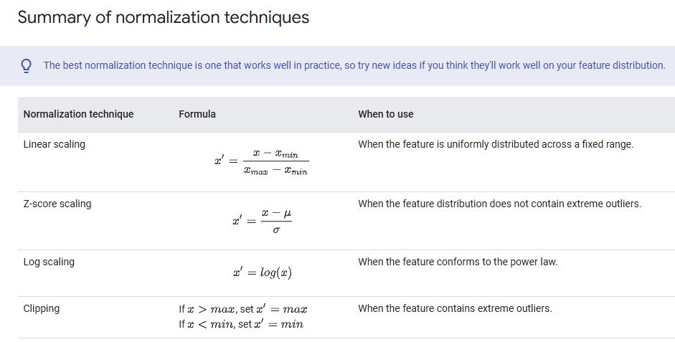

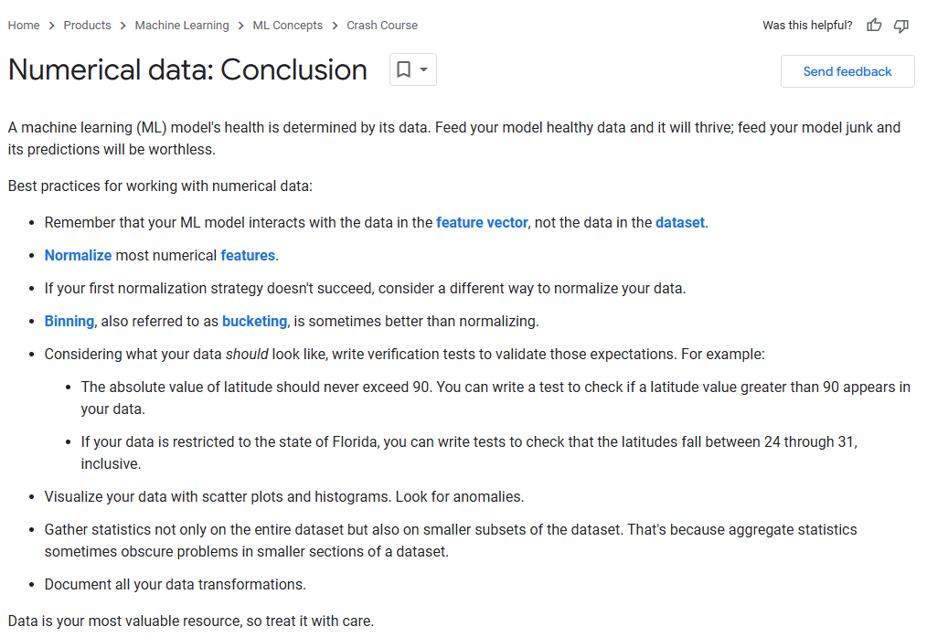

Rules of Machine Learning - Best Practices for ML Engineering
https://developers.google.com/machine-learning/guides/rules-of-ml#ml_phase_ii_feature_engineering

Datasets: Dividing the original dataset
bookmark_border
All good software engineering projects devote considerable energy to testing their apps. Similarly, we strongly recommend testing your ML model to determine the correctness of its predictions.
Training, validation, and test sets
You should test a model against a different set of examples than those used to train the model. As you'll learn a little later, testing on different examples is stronger proof of your model's fitness than testing on the same set of examples. Where do you get those different examples? Traditionally in machine learning, you get those different examples by splitting the original dataset. You might assume, therefore, that you should split the original dataset into two subsets:
- A training set that the model trains on.
- A test set for evaluation of the trained model.
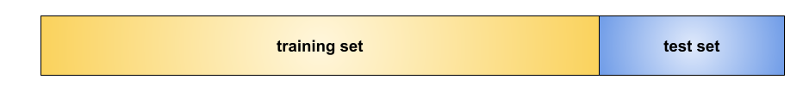Figure 8. Not an optimal split.

Exercise: Check your intuition
Suppose you train on the training set and evaluate on the test set over multiple rounds. In each round, you use the test set results to guide how to update hyperparameters and the feature set. Can you see anything wrong with this approach? Pick only one answer.
This approach is fine. After all, you're training on the training set and evaluating on a separate test set.
Doing many rounds of this procedure might cause the model to implicitly fit the peculiarities of the test set.
Yes! The more often you use the same test set, the more likely the model closely fits the test set. Like a teacher "teaching to the test," the model inadvertently fits the test set, which might make it harder for the model to fit real-world data.
Correct answer.
This approach is computationally inefficient. Don't change hyperparameters or feature sets after each round of testing.
Dividing the dataset into two sets is a decent idea, but a better approach is to divide the dataset into three subsets. In addition to the training set and the test set, the third subset is:
- A validation set performs the initial testing on the model as it is being trained.
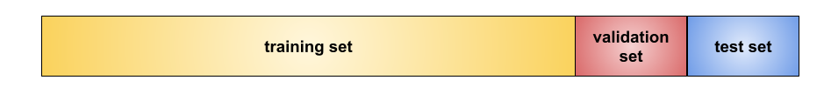Figure 9. A much better split.
Use the validation set to evaluate results from the training set. After repeated use of the validation set suggests that your model is making good predictions, use the test set to double-check your model.
The following figure suggests this workflow. In the figure, "Tweak model" means adjusting anything about the model —from changing the learning rate, to adding or removing features, to designing a completely new model from scratch. At the end of this workflow, you pick the model that does best on the test set.
Figure 10. A good workflow for development and testing.Note: When you transform a feature in your training set, you must make the same transformation in the validation set, test set, and real-world dataset.
The workflow shown in Figure 10 is optimal, but even with that workflow, test sets and validation sets still "wear out" with repeated use. That is, the more you use the same data to make decisions about hyperparameter settings or other model improvements, the less confidence that the model will make good predictions on new data. For this reason, it's a good idea to collect more data to "refresh" the test set and validation set. Starting anew is a great reset.

Additional problems with test sets
As the previous question illustrates, duplicate examples can affect model evaluation. After splitting a dataset into training, validation, and test sets, delete any examples in the validation set or test set that are duplicates of examples in the training set. The only fair test of a model is against new examples, not duplicates.
For example, consider a model that predicts whether an email is spam, using the subject line, email body, and sender's email address as features. Suppose you divide the data into training and test sets, with an 80-20 split. After training, the model achieves 99% precision on both the training set and the test set. You'd probably expect a lower precision on the test set, so you take another look at the data and discover that many of the examples in the test set are duplicates of examples in the training set. The problem is that you neglected to scrub duplicate entries for the same spam email from your input database before splitting the data. You've inadvertently trained on some of your test data.
In summary, a good test set or validation set meets all of the following criteria:
- Large enough to yield statistically significant testing results.
- Representative of the dataset as a whole. In other words, don't pick a test set with different characteristics than the training set.
- Representative of the real-world data that the model will encounter as part of its business purpose.
- Zero examples duplicated in the training set.

- Overfitting
- bookmark_border
- Overfitting means creating a model that matches (memorizes) the training set so closely that the model fails to make correct predictions on new data. An overfit model is analogous to an invention that performs well in the lab but is worthless in the real world.
- Tip: Overfitting is a common problem in machine learning, not an academic hypothetical.
- In Figure 11, imagine that each geometric shape represents a tree's position in a square forest. The blue diamonds mark the locations of healthy trees, while the orange circles mark the locations of sick trees.
- Figure 11. Training set: locations of healthy and sick trees in a square forest.

- Mentally draw any shapes—lines, curves, ovals...anything—to separate the healthy trees from the sick trees. Then, expand the next line to examine one possible separation.
- Expand to see one possible solution (Figure 12).
- Figure 12. A complex model for distinguishing sick from healthy trees.

- The complex shapes shown in Figure 12 successfully categorized all but two of the trees. If we think of the shapes as a model, then this is a fantastic model.
- Or is it? A truly excellent model successfully categorizes new examples. Figure 13 shows what happens when that same model makes predictions on new examples from the test set:
- Figure 13.Test set: a complex model for distinguishing sick from healthy trees.

- So, the complex model shown in Figure 12 did a great job on the training set but a pretty bad job on the test set. This is a classic case of a model overfitting to the training set data.
- Fitting, overfitting, and underfitting
- A model must make good predictions on new data. That is, you're aiming to create a model that "fits" new data.
- As you've seen, an overfit model makes excellent predictions on the training set but poor predictions on new data. An underfit model doesn't even make good predictions on the training data. If an overfit model is like a product that performs well in the lab but poorly in the real world, then an underfit model is like a product that doesn't even do well in the lab.
- Figure 14. Underfit, fit, and overfit models.

- Generalization is the opposite of overfitting. That is, a model that generalizes well makes good predictions on new data. Your goal is to create a model that generalizes well to new data.
- Detecting overfitting
- The following curves help you detect overfitting:
- loss curves
- generalization curves
- A loss curve plots a model's loss against the number of training iterations. A graph that shows two or more loss curves is called a generalization curve. The following generalization curve shows two loss curves:
- 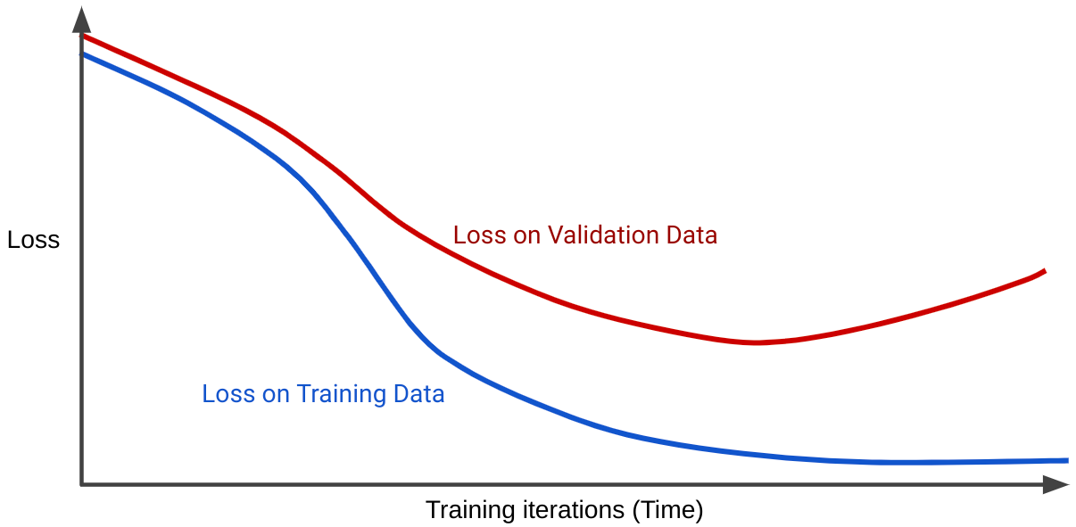Figure 15. A generalization curve that strongly implies overfitting.

- Notice that the two loss curves behave similarly at first and then diverge. That is, after a certain number of iterations, loss declines or holds steady (converges) for the training set, but increases for the validation set. This suggests overfitting.
- In contrast, a generalization curve for a well-fit model shows two loss curves that have similar shapes.
- What causes overfitting?
- Very broadly speaking, overfitting is caused by one or both of the following problems:
- The training set doesn't adequately represent real life data (or the validation set or test set).
- The model is too complex.
- Generalization conditions
- A model trains on a training set, but the real test of a model's worth is how well it makes predictions on new examples, particularly on real-world data. While developing a model, your test set serves as a proxy for real-world data. Training a model that generalizes well implies the following dataset conditions:
- Examples must be independently and identically distributed, which is a fancy way of saying that your examples can't influence each other.
- The dataset is stationary, meaning the dataset doesn't change significantly over time.
- The dataset partitions have the same distribution. That is, the examples in the training set are statistically similar to the examples in the validation set, test set, and real-world data.
- Explore the preceding conditions through the following exercises.

Neural networks
bookmark_border
Estimated module length: 75 minutesLearning objectives
- Explain the motivation for building neural networks, and the use cases they address.
- Define and explain the function of the key components of a deep neural network architecture:
  - Nodes
  - Hidden layers
  - Activation functions
- Develop intuition around how neural network predictions are made, by stepping through the inference process.
- Build a high-level intuition of how neural networks are trained, using the backpropagation algorithm.
- Explain how neural networks can be used to perform two types of multi-class classification: one-vs.-all and one-vs.-one.
Prerequisites:
This module assumes you are familiar with the concepts covered in the following modules:
- Introduction to Machine Learning
- Linear regression
- Logistic regression
- Classification
- Working with numerical data
- Working with categorical data
- Datasets, generalization, and overfitting
You may recall from the Feature cross exercises in the Categorical data module, that the following classification problem is nonlinear:
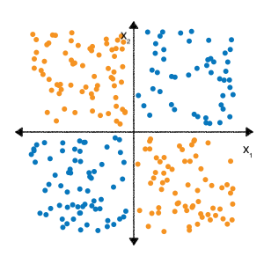Figure 1. Nonlinear classification problem. A linear function cannot cleanly separate all the blue dots from the orange dots.
"Nonlinear" means that you can't accurately predict a label with a model of the form b+w1x1+w2x2. In other words, the "decision surface" is not a line.
However, if we perform a feature cross on our features x1 and x2, we can then represent the nonlinear relationship between the two features using a linear model: b+w1x1+w2x2+w3x3 where x3 is the feature cross between x1 and x2:
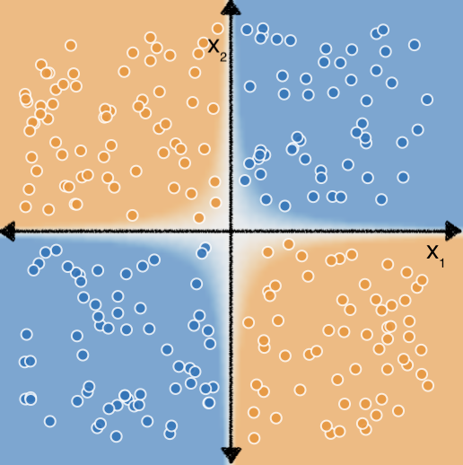Figure 2. By adding the feature cross x₁x₂, the linear model can learn a hyperbolic shape that separates the blue dots from the orange dots.
Now consider the following dataset:
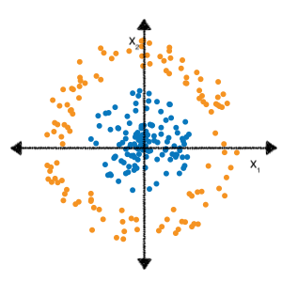Figure 3. A more difficult nonlinear classification problem.
You may also recall from the Feature cross exercises that determining the correct feature crosses to fit a linear model to this data took a bit more effort and experimentation.
But what if you didn't have to do all that experimentation yourself? Neural networks are a family of model architectures designed to find nonlinear patterns in data. During training of a neural network, the model automatically learns the optimal feature crosses to perform on the input data to minimize loss.
In the following sections, we'll take a closer look at how neural networks work.

